Exercise 2 - Implementing the Factory Method Pattern
Created a new Java project named FactoryMethodPatternExample –

Defining the Document Interface and Concrete Classes –
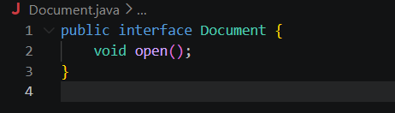
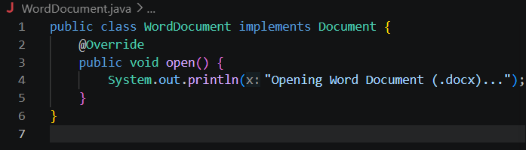
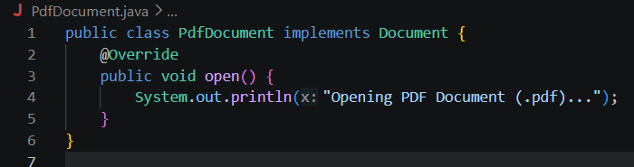
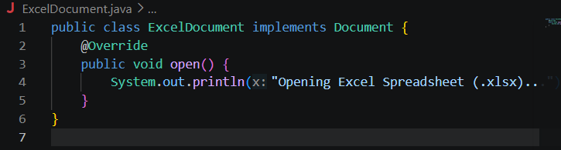
Implementing the Factory Method –
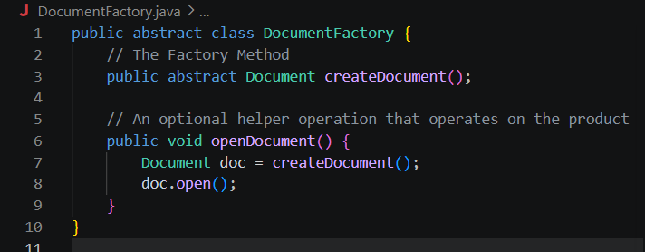
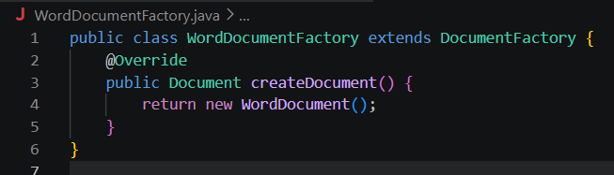
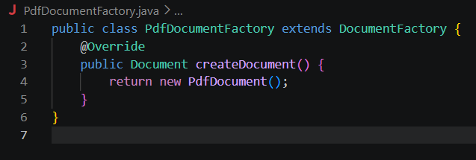
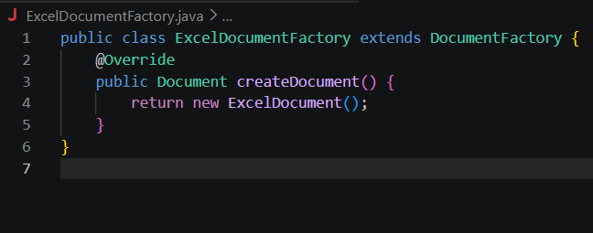
Implementation of the Test of the Factory Method –
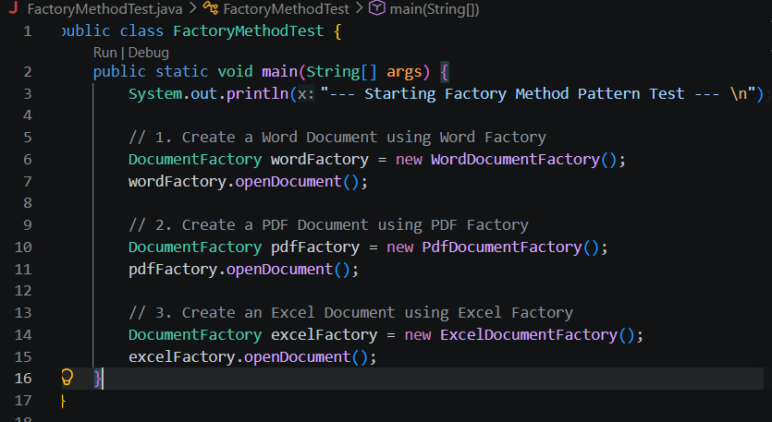
CODE OUTPUT:
